|  |  |  |
| --- | --- | --- |
|  |  | |
| C:\Users\kperrin\Desktop\February 2017\P1030237.JPG |  | **Alexandria Arlington**  **Resource Recovery Facility**  Fiscal Year 2017  Third Quarter Operations Report  **May 2017** |
| C:\Users\kperrin\Desktop\February 2017\P1030236.JPG |  |
| **Prepared by:**  **HDR Engineering, Inc.**  **5426 Bay Center Drive, Suite 400**  **Tampa, Florida 33609-3444** | C:\Users\kperrin\Desktop\February 2017\P1030227.JPG | |
|  |  | |

Table of Contents

Section No. Page No.

1.0 Purpose of Report 4

2.0 Executive Summary 4

3.0 Facility Inspection and Records Review 5

4.0 Facility Performance 9

4.1 Utility and Reagent Consumptions 22

4.2 Safety & Environmental Training 23

5.0 Facility Maintenance 24

5.1 Availability 28

5.2 Downtime Summary 29

5.3 Facility Housekeeping 31

6.0 Environmental 32

6.1 Nitrogen Oxide Emissions 32

6.2 Sulfur Dioxide Emissions 32

6.3 Carbon Monoxide Emissions 32

6.4 Opacity 33

6.5 Daily Emissions Data 33

6.6 Ash System Compliance 33

APPENDIX A FACILITY CEMS DATA 35

APPENDIX B PHOTOS 39

**Front Cover Photos**

**Top:** General Photo – Turbine Generator Control Panel in Control Room

**Middle:** Administration Building Renovations in Progress

**Bottom:** General Facility Photo from up Eisenhower

List of Tables

Table No. Page No.

Table 1: Summary of Inspection Report Deficiencies 7

Table 2: Quarterly Performance Summaries 15

Table 3: Waste Delivery Classification 17

Table 4: Facility Utility and Reagent Consumptions 22

Table 5: Quarterly Facility Unit Availabilities 28

Table 6: Boiler Downtime – Q3FY17 29

Table 7: Turbine Generator Downtime – Q3FY17 30

Table 8: Facility Housekeeping Ratings – February 2017 31

Table 9: Unit #1 Monthly Summary for Reportable Emissions Data 36

Table 10: Unit #2 Monthly Summary for Reportable Emissions Data 37

Table 11: Unit #3 Monthly Summary for Reportable Emissions Data 38

List of Charts

Chart No. Page No.

Chart 1: Tons of Waste Processed 9

Chart 2: Tons of Ash Produced per Ton of Waste Processed 10

Chart 3: Ferrous Recovery Rate 11

Chart 4: Steam Production 12

Chart 5: 12-Month Rolling Steam Production 13

Chart 6: Steam Production Rate 14

Chart 7: Calculated Waste Heating Value 15

Chart 8: Cumulative Total Waste Delivery 18

Chart 9: Gross Electrical Generation 18

Chart 10: Gross Conversion Rate 19

Chart 11: Net Conversion Rate 20

Chart 12: Net Conversion Rate 20

Chart 13: Gross Turbine Generator Conversion Rate 21

Chart 14: Net Turbine Generator Conversion Rate 22

Chart 15: Quarterly Ash Test Results 34

List of Figures

Figure No. Page No.

Figure 1: Housing Damaged of Self Contained Breathing Apparatus (SCBA) – North Charging Floor Entrance – New Deficiency 40

Figure 2: Tipping Floor Center Bay eroded and rebar exposed – New Deficiency 40

Figure 3: New refuse pit warning laser lights – red line projected near refuse pit edge 40

Figure 4: Ceiling mounted laser projector for refuse pit warning laser system – multiple units installed all the way across Tipping Enclosure Roof 40

Figure 5: General Facility Photo – Northeast Corner 40

Figure 6: General Facility Photo 40

Figure 7: Ash Trailer Canopy 41

Figure 8: Ammonia Storage Tank 41

Figure 9: Administration Office Space Renovations – In Progress 41

Figure 10: First floor restrooms completely renovated 41

Figure 11: Administration Office 1st Floor Lobby Renovations – In Progress 41

Figure 12: New Covanta Signed – Freshly painted 41

Figure 13: Outage materials staged throughout Barn Door Elevation – awaiting Spring Outages 42

Figure 14: General Photo – Economizer Area 42

Figure 15: Multiple Cooling Tower Access Stairs replaced with new pressure treated wood 42

Figure 16: Grate bars awaiting installation during Spring Outages 42

Figure 17: Circulating Water Pumps – east side of Cooling Tower 42

Figure 18: Tipping Floor – General Photo 42

Figure 19: Metal Roll-Off 43

Figure 20: Citizen’s Drop – Roll-off 43

Figure 21: Firing Aisle 43

Figure 22: Turbine Generator Enclosure 43

Figure 23: Cooling Towers from SDA Penthouse 43

Figure 24: Deaerator 43

Figure 25: SCBA at north Charging Floor Entrance 44

Figure 26: Fire House at east Tipping Enclosure Wall – No Issues Observed 44

Figure 27: Charging Floor Fire Cannon on West side of Refuse Pit Parapet – No Issues Observed 44

Figure 28: Charging Floor Fire Cannon, north end of Charging Floor - No Issues Observed 44

Figure 29: Fire Hose north end of Charging Floor – No issues observed 44

Figure 30: Fire Alarm Operator Interface in Control Room - CAAI 2017 Budget Item to upgrade 44

**Definition of Abbreviations & Acronyms**

|  |  |
| --- | --- |
| Abbreviation/Acronym | Definition |
| APC | Air Pollution Control |
| Apr | April |
| Aug | August |
| Avg | Average |
| Btu | British thermal unit |
| CAAI | Covanta Alexandria Arlington, Inc. |
| CEMS | Continuous Emissions Monitoring System |
| CO | Carbon Monoxide |
| Dec | December |
| ECOM | Emergency Communications |
| Feb | February |
| FMG | Facility Monitoring Group |
| FY | Fiscal Year |
| gal | Gallon |
| GAT | Guaranteed Annual Tonnage |
| HCl | Hydrochloric (Hydrogen Chlorides) |
| HDR | HDR Engineering Inc |
| HHV | Estimated Waste Heating Value (Btu/lb) |
| ID | Induced Draft |
| Jan | January |
| Jul | July |
| Jun | June |
| klbs | Kilo-pounds (1,000 lbs) |
| kWhr | Kilowatt hours (1,000 watt-hours) |
| lbs | Pounds |
| LOA | Letter of Agreement |
| Mar | March |
| Max | Maximum |
| May | May |
| Min | Minimum |
| MSW | Municipal Solid Waste |
| MWhr | Megawatt hours |
| No | Number |
| NOV | Notice of Violation |
| Nov | November |
| NOx | Nitrogen Oxide |
| Oct | October |
| OSHA | Occupational Safety and Health Administration |
| PDS | Potomac Disposal Services |
| ppm | Parts per million |
| ppmdv | Parts per million dry volume |
| PSD | Prevention of Significant Deterioration |
| Q1 | First Quarter |
| Q2 | Second Quarter |
| Q3 | Third Quarter |
| Q4 | Fourth Quarter |
| RE | Reportable Exempt |
| RNE | Reportable Non-Exempt |
| SDA | Spray Dryer Absorber |
| Sep | September |
| SO2 | Sulfur Dioxide |
| TCLP | Toxicity Characteristic Leaching Procedure |
| VADEQ | Virginia Department of Environmental Quality |
| WL | Warning Letter |
| yr | Year |
| YTD | Year to date |

Alexandria/Arlington Waste-to-Energy Facility

Third Quarter Operations Report – Fiscal Year 2017

# Purpose of Report

HDR Engineering, Inc. (HDR) was authorized by the Facility Monitoring Group (FMG) to conduct quarterly inspections and provide quarterly reports regarding the operation and maintenance of the Covanta Alexandria/Arlington Waste-to-Energy Facility (Facility) for the 2017 calendar year. This report is prepared for the Third quarter of the 2017 fiscal year and summarizes Facility operations between January 1, 2017 and March 31, 2017. This report identifies the fiscal year beginning on July 1, 2016 as FY17 and the quarter beginning on January 1, 2017 as Q3FY17.

This report is based upon HDR’s experience in the waste-to-energy industry, upon site observation visits and previous reports provided by HDR, and upon data provided by Covanta Alexandria / Arlington, Inc. (CAAI), the Facility owner and operator.

# Executive Summary

CAAI operated the Facility in an acceptable manner and in accordance with established waste-to-energy industry practices during Q3FY17. The operation of the Facility, maintenance, safety, and overall cleanliness continue to be above average. Environmental performance was excellent with no reportable environmental excursions throughout the quarter.

During Q3FY17, the Facility experienced two (2) instances of unscheduled downtime for the boilers totaling 32.0 hours, and one (1) instance of unscheduled downtime for turbine generators totaling 11.5 hours. The boilers experienced 512.5 hours of downtime for two (2) scheduled outages, and a scheduled cold iron outage during Q3FY17. The turbine generators experienced 72.0 hours of downtime for one (1) scheduled outage and the scheduled cold iron outage. During the quarter, the boilers experienced 143.5 hours of standby time, and the turbine generators experienced 343.6 hours of standby time. Note that standby time is not factored into overall availability. A detailed listing of downtime is provided in Section 5.2 of this report.

Average waste processed during the quarter was 914.1 tons per day, or 93.8% of nominal facility capacity. Waste deliveries averaged 897.4 tons per day, which is 1.8% lower than the burn rate. The capacity utilization of 93.8% is comparable to that of mature, well run waste to energy facilities.

Performance trends for various measurements are presented in Section 4. In general, the Facility continues to demonstrate reasonable consistency in month to month performance throughout the most recent three-year period tracked for detailed comparisons.

During the quarter, MSW processed slightly increased (0.2%) from the corresponding quarter in FY16; steam production decreased (2.3%), and electricity generated (gross) decreased (1.0%) from the corresponding quarter in FY16. The decrease in steam generation is attributable to more boiler downtime (126 additional hours), paired with a decrease (0.5%) in calculated waste heating value. The decrease in electricity generated (gross) in Q3FY17, is attributable to lower steam production, and more downtime (139.5 additional hours) experienced by the turbine generators. CAAI continues to throttle back the boiler steam load as necessary to stay below the steam production limit.

# Facility Inspection and Records Review

In February 2017, HDR met with the Facility management and other plant personnel to discuss Facility operations and maintenance, acquire data and reports, perform an independent visual inspection of the operating Facility, photograph areas of interest, and perform a review of recent Facility activity. This visit was coordinated with the scheduled FMG meeting. At the time of the inspection, HDR reviewed CAAI records, discussed performance issues with CAAI staff, and provided a verbal report and performance statistics at the February 2017 FMG meeting. HDR maintains a running tabulation of the status of corrective actions and plant performance trends. CAAI provides the following documents for each month:

* Facility Monthly Operating Reports
* Monthly Continuous Emissions Monitoring System (CEMS) Reports

Table 1 summarizes maintenance, repair, and plant condition issues reported during this and prior reporting periods. An “A” indicates an issue of the highest priority and worthy of immediate attention. Such items are usually safety or operability issues. A “B” indicates that the issue needs to be dealt with as quickly as possible, but is not urgent. These items will usually result in a process improvement or will help avoid future “urgent” issues. A “C” indicates that the issue should be dealt with at the earliest convenience, but is not a priority issue. This category might include issues related to aesthetics, non-urgent maintenance, or housekeeping improvements which are not safety related.

Note that HDR inspections are generally performed while equipment is operating, and are not intended to address the internal condition, performance or life expectancy of mechanical, electrical and electronic equipment and structures. HDR inspections are only performed quarterly, generally representing findings on the day of the inspection. CAAI is responsible, without limitation, for operations, maintenance, environmental performance and safety and should not rely on HDR observations or inspection reports which are overviews of Facility external conditions only.

Table 1: Summary of Inspection Report Deficiencies

*A is highest priority & demands immediate attention: B needs attention, but is not urgent; C can be addressed at earliest opportunity & is not urgent.

| Item No. | Inspection Report Deficiencies | Issue Reported | Priority* | HDR Recommendation | Status | Open / Closed |
| --- | --- | --- | --- | --- | --- | --- |
| 1 | Corrosion on ceiling panels in Turbine Generator Enclosure | August 2014 | C | Sand, Prime, Paint and Preserve, and replace deteriorated panels as necessary | **HDR observed the corroded/deteriorated sections had been primed, but no panels were replaced. CAAI reports that it plans to replace panels in 1 to 2 years.** | Open |
| 2 | Corrosion on ceiling panels in Turbine Generator Enclosure (Alternate Location) | August 2014 | C | Sand, Prime, Paint and Preserve, and replace deteriorated panels as necessary | **HDR observed the corroded/deteriorated sections had been primed, but no panels were replaced. CAAI reports that it plans to replace panels in 1 to 2 years.** | Open |
| 3 | Deteriorated purlin east wall in Tipping Floor Enclosure | November 2014 | C | Replace deteriorated purlin | **CAAI reports that it will replace sections of the east wall of the Tipping Floor Enclosure as a 2016 Budget Item.** | Open |
| 4 | Induced Draft Fan No. 1 Lagging deteriorated, west side of CEMS Enclosure | May 2015 | C | Replace deteriorated Induced Draft Fan Lagging | **Status Unchanged** | Open |
| 5 | Pot hole, southeast corner of Ash Trailer Canopy | August 2015 | C | Repair road surface | **Status Unchanged** | Open |
| 6 | Chemical storage container deteriorated, north of Main Vibrating Pan, at ground elevation | February 2016 | C | Replace storage container | **During the August 2016 FMG Meeting, CAAI indicated it planned to purchase a new storage container and dispose of the deteriorated container.** | Open |
| 7 | Safety Cage on Rotary Sootblower No. 27 detached and gears exposed | August 2016 | A | Adjust rotary sootblower cage to shield exposed gears | **Complete** | Closed |
| 8 | Underside of grating deteriorated, upper elevations of all three economizers | August 2016 | C | Replace economizer grating in upper elevations | **Status Unchanged** | Open |
| 9 | Pavement spider-cracking at Tipping Floor Entrance | November 2016 | C | Resurface section of pavement at Tipping Floor Entrance | **Status Unchanged** | Open |
| 10 | Concrete slab damaged that Citizen’s Drop-off Roll-off is on | November 2016 | C | Repair concrete slab | **Status Unchanged** | Open |
| 11 | Pothole where Tipping Floor Exit Road enters Eisenhower Avenue | November 2016 | C | Repair pothole | **Status Unchanged** | Open |
| 12 | Multiple Cooling Tower Access Stairs Split | November 2016 | A | Replace damaged stairs | **Complete** | Closed |
| 13 | Corrosion on Scale House | November 2016 | C | Conduct proper painting preservation measures on corroded spots of Scale House | **Status Unchanged** | Open |
| 14 | Housing Damaged of Self Contained Breathing Apparatus (SCBA) – North Charging Floor Entrance –– See Figure 1 (Appendix B) | February 2017 | C | Replace SCBA Enclosure | **Status Unchanged** | Open |
| 15 | Tipping Floor Center Bay concrete apron eroded and rebar exposed –– See Figure 2 (Appendix B) | February 2017 | C | Resurface eroded section of Tipping Floor near refuse pit | **Status Unchanged** | Open |

# Facility Performance

Monthly operating data provided by CAAI indicates that 82,267 tons of MSW were processed during Q3FY17, and a total of 80,768 tons of MSW including 3,787 tons of Special Handling Waste were received. Total ash production during the quarter was 16,497 tons, which represents 20.1% of the waste processed by weight. The average uncorrected steam production rate for Q3FY17 was 2.93 tonssteam/tonwaste, which is lower (2.6%) than the corresponding quarter in FY16. The decrease in this metric does not correlate with the 0.5% decrease in the average waste heating value (HHV) calculated by CAAI, and is indicative of poorer boiler performance or some other currently unidentified cause. This trend continues to be unexplained.

Chart 1: Tons of Waste Processed

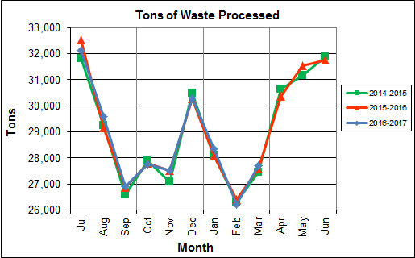

Chart 1 illustrates that Q3FY17 waste processed was slightly higher (0.2%) than the corresponding quarter, Q3FY16.

CAAI reported that 465 tipping floor/MSW internal inspections were conducted during the quarter and seven (7) notices of violation (NOVs) were issued to haulers for the following issues:

* March 2017 – Seven (7) NOVs were issued for not following the rules regarding lining up and blocking the Tipping Floor Entrance.

Chart 2: Tons of Ash Produced per Ton of Waste Processed

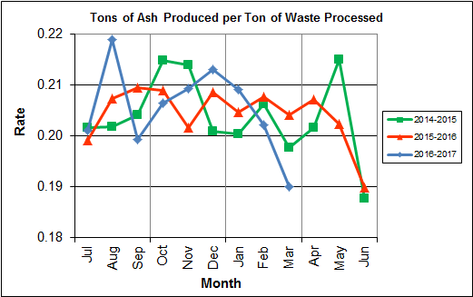

Chart 2 illustrates that the average ash production rate in Q3FY17 was slightly higher (0.1%) at 20.1% of processed waste, compared to the corresponding quarter in FY16 when the rate was 20.0%. Ash production remains in the 20.0% to 21.0% range, as a result of the installation of the “semi-dry” ash discharger spray system in May 2012, and represents less moisture in the ash residue shipped to disposal.

Chart 3: Ferrous Recovery Rate

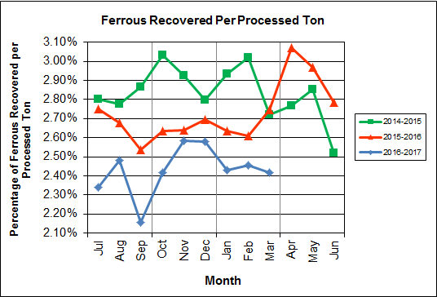

Chart 3 depicts the monthly ferrous metal recovery rate as a percentage of processed MSW tonnage. In Q3FY17, 2,002 tons of ferrous metals were recovered, which is 8.5% lower than the corresponding quarter in FY16 and equivalent to 2.4% of processed waste. Ferrous metal recovery remains significantly below prior results. CAAI attributes the significant decline to an increase in recycling rates resulting in less metal in the MSW. CAAI previously indicated that it replaced an end section of the vibrating pan during Q1FY16 which was worn due to wear from material getting caught between the pan and magnet.

Chart 4: Steam Production

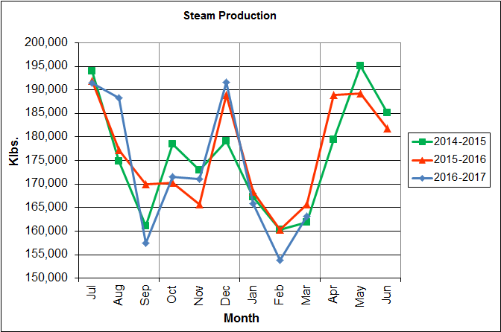

In Chart 4, the total steam production for Q3FY17 was 482,727 klbs., and lower (2.3%) than the corresponding quarter in FY16. The decrease in steam generation is attributable to more downtime (126 additional hours), paired with a decrease (0.5%) in calculated waste heating value, and CAAI throttling the boilers back to stay below the steam production limit.

Chart 5: 12-Month Rolling Steam Production

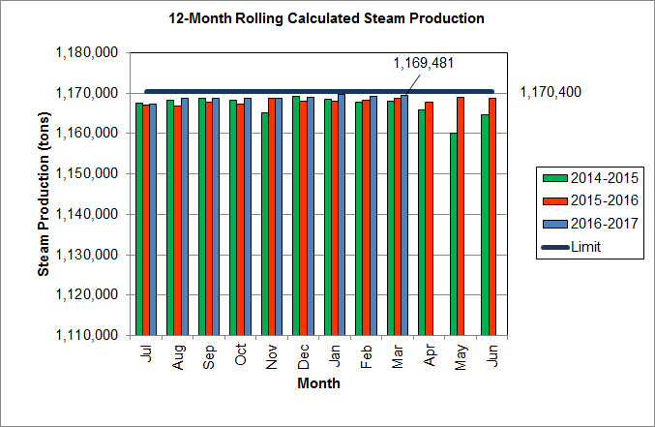

Chart 5 depicts the 12-month rolling steam production total for the period ending in March 2017. According to the Title V permit, the annual steam production for the Facility shall not exceed 1,170,400 tons on the basis of an average value of 3.34 lbs of steam per lb of MSW processed, calculated monthly as the sum of each consecutive 12 month period. The Facility was in compliance with the 12-month rolling steam production total every month in Q3FY17. The 12-month rolling total for steam production ending in March 2017 was 1,169,481 tons which is 99.9% of the limit. Chart 5 clearly shows that Facility throughput, and in turn, steam and electricity production are being throttled to stay ever so slightly below the steam production limit nearly every month.

Chart 6: Steam Production Rate

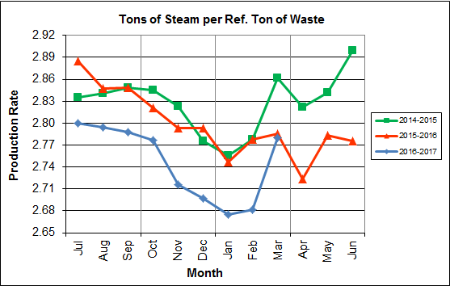\

In Chart 6, the conversion of raw waste tonnages into “reference tons” is another way of analyzing steam production, and helps to determine whether changes are related to boiler performance or to fuel issues. “Reference tons” are adjusted to account for the calculated average fuel heating value, so that lower Btu fuel raw tonnages are adjusted upwards and vice versa. In Q3FY17, this metric tracked lower (2.1%) at 2.7 tonssteam/tonref, compared to the corresponding quarter in FY16. This trend continues to show ongoing deterioration of boiler performance since July of 2016.

Chart 7: Calculated Waste Heating Value

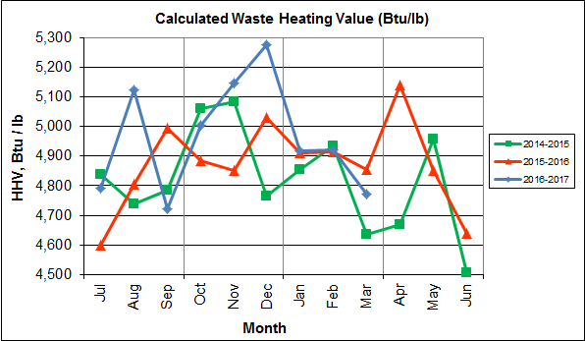

Chart 7 illustrates that Q3FY17 calculated average waste heating value was lower (0.5%) at 4,870 Btu/lb than the corresponding quarter Q3FY16, which averaged 4,893 Btu/lb.

Table 2: Quarterly Performance Summaries

|  |  |  |  |  |  |  |  |  |
| --- | --- | --- | --- | --- | --- | --- | --- | --- |
| Month | | Waste Processed (tons) | Waste Diverted  (tons) | Ash Shipped  (tons) | Special Handling (Supplemental)  (tons) | Ferrous Recovered  (tons) | Steam Produced (klbs) | Net Electrical Generation  (MWhr) |
| **Q3FY15** | **Quarterly Totals** | **81,876** | **0** | **16,486** | **1,012** | **2,366** | **489,283** | **34,193** |
| January -15 | 28,114 | 0 | 5,632 | 389 | 825 | 167,202 | 11,777 |
| February -15 | 26,301 | 0 | 5,426 | 351 | 794 | 160,221 | 11,322 |
| March - 15 | 27,461 | 0 | 5,428 | 272 | 747 | 161,860 | 11,094 |
| **Q3FY16** | **Quarterly Totals** | **82,085** | **0** | **16,867** | **2,284** | **2,187** | **494,295** | **34,595** |
| January -16 | 28,091 | 0 | 5,748 | 642 | 740 | 168,391 | 11,902 |
| February -16 | 26,414 | 0 | 5,487 | 850 | 689 | 160,228 | 11,192 |
| March – 16 | 27,580 | 0 | 5,632 | 792 | 758 | 165,676 | 11,501 |
| **Q3FY17** | **Quarterly Totals** | **82,267** | **0** | **16,497** | **3,787** | **2,002** | **482,727** | **34,355** |
| January -17 | 28,353 | 0 | 5,931 | 1,083 | 689 | 165,770 | 11,933 |
| February -17 | 26,217 | 0 | 5,302 | 1,413 | 644 | 153,757 | 11,067 |
| March - 17 | 27,697 | 0 | 5,264 | 1,291 | 669 | 163,200 | 11,355 |
| **FY17 YTD Totals** | | **256,492** | **0** | **52,757** | **8,569** | **6,231** | **1,553,963** | **110,310** |
| **FY16 Totals** | | **349,881** | **0** | **71,401** | **8,567** | **9,571** | **2,118,125** | **148,529** |
| **FY15 Totals** | | **348,686** | **0** | **71,019** | **5,413** | **9,864** | **2,109,442** | **145,085** |

Table 2 presents the production data provided to HDR by CAAI for Q3FY17 on both a monthly and quarterly basis. For purposes of comparison, data for Q3FY15 and Q3FY16 are also shown, as well as FY15, FY16 and FY17 YTD totals.

In comparing quarterly totals, the data shows:

* Slightly more waste was processed in Q3FY17 than Q3FY16 and Q3FY15
* Less steam was generated in Q3FY17 than Q3FY16 and Q3FY15
* Slightly Less electricity was generated in Q3FY17 than Q3FY16 and more than in Q3FY15
* Significantly more supplemental waste was received in Q3FY17 than Q3FY16 and Q3FY15.

Please note that the total steam generation figures presented in Table 2 do not correlate with the annual steam production limit from the Facility Permit; such limits apply on a rolling average monthly basis, and not a fiscal year basis. It is also worth noting that the quantity of waste processed during Q3FY17 continues to be limited by the steam production permit restrictions (refer to Chart 5).

Table 3: Waste Delivery Classification

|  |  |  |  |  |  |  |  |  |  |  |  |  |  |  |  |
| --- | --- | --- | --- | --- | --- | --- | --- | --- | --- | --- | --- | --- | --- | --- | --- |
|  |  | **Jul** | **Aug** | **Sep** | **Oct** | **Nov** | **Dec** | **Jan** | **Feb** | **Mar** | **Apr** | **May** | **Jun** | **Totals** | **% of Total** |
| **FY13** | **Jurisdiction Waste** | 19,413 | 18,357 | 16,632 | 17,625 | 18,838 | 16,195 | **-** | **-** | **-** | **-** | **-** | **-** | 107,058 | 30.76% |
| **Spot Waste tons** | 10,516 | 11,326 | 10,610 | 10,317 | 9,330 | 9,558 | **-** | **-** | **-** | **-** | **-** | **-** | 61,656 | 17.72% |
| **City Waste** | **-** | **-** | **-** | **-** | **-** | **-** | 1,683(1) | 1,287 | 1,444 | 2,382 | 2,286 | 1,919 | 11,000 | 3.16% |
| **County Waste** | **-** | **-** | **-** | **-** | **-** | **-** | 2,442(1) | 2,100 | 2,372 | 3,381 | 3,932 | 3,309 | 17,536 | 5.04% |
| **Municipal Solid Waste** | **-** | **-** | **-** | **-** | **-** | **-** | 25,019(1) | 23,637 | 21,661 | 27,066 | 25,794 | 24,930 | 148,107 | 42.56% |
| **Supplemental Waste** | 151 | 11 | 80 | 25 | 234 | 405 | 363 | 365 | 76 | 403 | 281 | 271 | 2,665 | 0.77% |
| **MSW Totals** | **29,928** | **29,683** | **27,241** | **27,942** | **28,167** | **25,753** | **29,507** | **27,388** | **25,552** | **33,231** | **32,293** | **30,429** | **348,022** | **100.00%** |
|  |  | **Jul** | **Aug** | **Sep** | **Oct** | **Nov** | **Dec** | **Jan** | **Feb** | **Mar** | **Apr** | **May** | **Jun** | **Totals** | **% of Total** |
| **FY14** | **City Waste** | 2,065 | 1,693 | 1,702 | 1,924 | 1,566 | 1,780 | 1,529 | 1,231 | 1,556 | 2,256 | 2,203 | 1,883 | 21,389 | 6.11% |
| **County Waste** | 3,459 | 3,079 | 2,784 | 3,091 | 2,707 | 2,802 | 2,568 | 1,957 | 2,272 | 3,326 | 3,987 | 3,387 | 35,419 | 10.12% |
| **Municipal Solid Waste** | 26,167 | 23,604 | 22,034 | 23,354 | 21,879 | 25,531 | 23,869 | 22,523 | 23,198 | 25,414 | 27,206 | 24,812 | 289,590 | 82.75% |
| **Supplemental Waste** | 546 | 676 | 248 | 410 | 188 | 268 | 275 | 192 | 231 | 253 | 151 | 110 | 3,548 | 1.01% |
| **MSW Totals** | **32,237** | **29,053** | **26,768** | **28,779** | **26,340** | **30,380** | **28,241** | **25,903** | **27,256** | **31,249** | **33,546** | **30,193** | **349,946** | **100.00%** |
|  |  | **Jul** | **Aug** | **Sep** | **Oct** | **Nov** | **Dec** | **Jan** | **Feb** | **Mar** | **Apr** | **May** | **Jun** | **Totals** | **% of Total** |
| **FY15** | **City Waste** | 1,814 | 1,497 | 1,699 | 1,737 | 1,518 | 1,770 | 1,411 | 1,209 | 1,648 | 2,155 | 2,059 | 2,045 | 20,562 | 5.91% |
| **County Waste** | 3,297 | 2,868 | 2,973 | 3,095 | 2,508 | 2,852 | 2,358 | 1,833 | 2,411 | 3,269 | 3,652 | 3,572 | 34,687 | 9.96% |
| **Municipal Solid Waste** | 26,661 | 24,466 | 21,887 | 21,241 | 21,678 | 27,906 | 24,611 | 20,915 | 24,094 | 25,189 | 23,126 | 25,667 | 287,442 | 82.57% |
| **Supplemental Waste** | 141 | 275 | 329 | 521 | 764 | 529 | 389 | 351 | 272 | 613 | 531 | 698 | 5,413 | 1.55% |
| **MSW Totals** | **31,913** | **29,106** | **26,888** | **26,595** | **26,468** | **33,057** | **28,769** | **24,308** | **28,424** | **31,225** | **29,369** | **31,982** | **348,105** | **100.00%** |
|  |  | **Jul** | **Aug** | **Sep** | **Oct** | **Nov** | **Dec** | **Jan** | **Feb** | **Mar** | **Apr** | **May** | **Jun** | **Totals** | **% of Total** |
| **FY16** | **City Waste** | 1,960 | 1,563 | 1,723 | 1,645 | 1,685 | 1,872 | 1,147 | 1,619 | 1,811 | 2,024 | 1,950 | 2,220 | 21,219 | 6.03% |
| **County Waste** | 3,627 | 2,880 | 2,832 | 2,869 | 2,682 | 2,891 | 2,025 | 2,389 | 2,694 | 2,406 | 2,508 | 2,661 | 32,465 | 9.22% |
| **Municipal Solid Waste** | 27,933 | 22,999 | 22,552 | 22,850 | 20,679 | 26,138 | 22,632 | 22,781 | 22,935 | 24,388 | 26,561 | 27,355 | 289,801 | 82.32% |
| **Supplemental Waste** | 676 | 427 | 771 | 684 | 676 | 787 | 642 | 850 | 792 | 996 | 605 | 661 | 8,565 | 2.43% |
| **MSW Totals** | **34,196** | **27,869** | **27,878** | **28,047** | **25,722** | **31,687** | **26,446** | **27,639** | **28,232** | **29,814** | **31,623** | **32,896** | **352,049** | **100.00%** |
|  |  | **Jul** | **Aug** | **Sep** | **Oct** | **Nov** | **Dec** | **Jan** | **Feb** | **Mar** | **Apr** | **May** | **Jun** | **YTD Totals** | **YTD**  **% of Total** |
| **FY17** | **City Waste** | 1,678 | 1,836 | 1,668 | 1,722 | 1,817 | 1,708 | 1,597 | 1,452 | 1,604 |  |  |  | 15,081 | 5.93% |
| **County Waste** | 2,386 | 2,469 | 2,370 | 2,184 | 2,321 | 2,289 | 2,287 | 2,016 | 2,517 |  |  |  | 20,839 | 8.19% |
| **Municipal Solid Waste** | 24,862 | 26,976 | 22,760 | 22,110 | 21,598 | 25,996 | 24,218 | 20,888 | 20,401 |  |  |  | 209,809 | 82.50% |
| **Supplemental Waste** | 504 | 642 | 734 | 926 | 941 | 1,036 | 1,083 | 1,413 | 1,291 |  |  |  | 8,570 | 3.37% |
| **MSW Totals** | **29,430** | **31,922** | **27,532** | **26,941** | **26,677** | **31,030** | **29,185** | **25,769** | **25,814** |  |  |  | **254,299** | **100.00%** |
| **Note (1): Beginning January 2013, the method in which waste was classified was modified as compared to prior periods due to change in contractual obligations and plant ownership** | | | | | | | | | | | | | | | |

Chart 8: Cumulative Total Waste Delivery

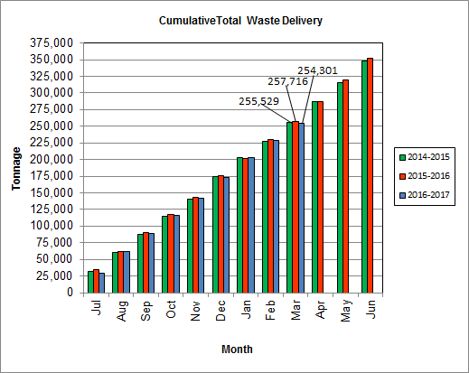

As depicted in Table 3 and Chart 8, for the quarter ending in March 2017; cumulative total waste delivery was 1.3% less compared to the same period in FY16.

Chart 9: Gross Electrical Generation

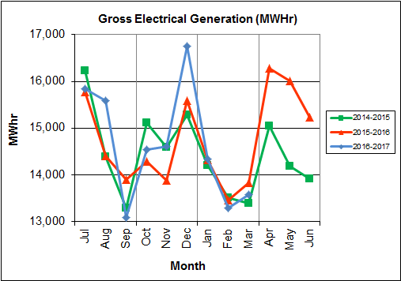

During Q3FY17, the Facility generated 41,202 MWhrs (gross) of electricity compared to Q3FY16 generation of 41,606 MWhrs (gross), a 1.0% decrease. The decrease in electricity generated (gross) in Q3FY17, is attributable to lower steam production, and more downtime (139.5 additional hours) experienced by the turbine generators. Note that the sharp spikes depicted in Chart Nos. 10 through 14 for the months of May and June 2015 are a result of significant downtime (424.7 hours) experienced by Turbine Generator No. 1 to repair an exciter failure.

Chart 10: Gross Conversion Rate

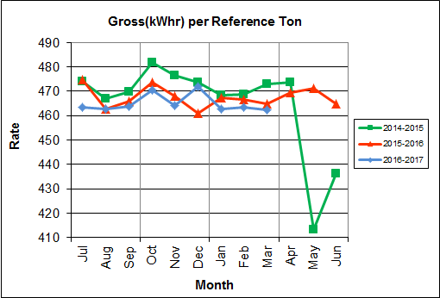

As shown in Chart 10, the average gross electrical generation per reference ton of refuse processed during Q3FY17 was 463kWhr, which is 0.7% lower than the corresponding quarter in FY16, and is attributable to more downtime experienced by the turbine generators during the quarter when compared to the corresponding quarter in FY16. Since this calculated value uses reference or normalized tonnages of waste, it should cancel the effect of MSW heating value (Btu content) variability.

Chart 11: Net Conversion Rate

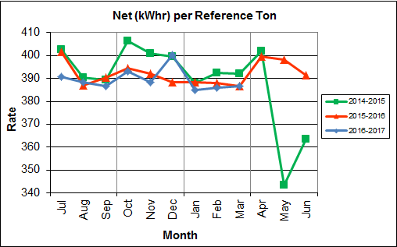

Chart 11 depicts the normalized net power (gross minus in-house usage) generation history. In Q3FY17, the average net electrical generation per reference ton was 386 kWhr, which is 0.4% lower than the corresponding quarter in FY16.

Chart 12: Net Conversion Rate

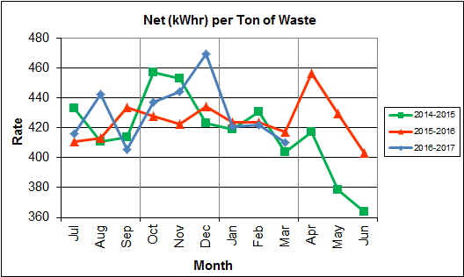

Chart 12 depicts the net power generation per processed ton. The net electrical generation per processed ton in Q3FY17 was 418 kWhr, which is 0.9% lower than the corresponding quarter in FY16, is attributable to lower steam production, and more downtime (139.5 additional hours) experienced by the turbine generators when compared to the corresponding quarter last fiscal year.

Chart 13: Gross Turbine Generator Conversion Rate

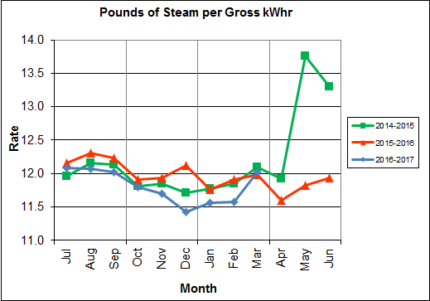

Charts 13 and 14 illustrate the quantities of steam required to generate one (1) kWhr of electricity, gross and net respectively. This measure is a turbine generator performance indicator, where lower steam rates indicate superior performance. For simplification, this calculated rate is based on the average for the two turbine generators. In Q3FY17 the average lbs of steam consumed per gross kWhr generated was 11.7, which is 1.4% lower (improved) than the corresponding quarter Q3FY16. A factor that negatively impacts this metric is Turbine Generator No. 2 continues to operate with its Stage 9 blades removed from the rotor. CAAI reported that during the Turbine Generator No. 2 overhaul in November 2013, some cracking was observed on the Stage 9 blades of the rotor, and the blading in that row was removed as a precautionary measure. CAAI originally indicated that a new set of blades would be manufactured and installed during a Turbine Generator No. 2 Outage in 2016, but advised in May 2015, that the implementation of the replacement blades installation would be delayed, and did not provide a date for repair. The average lbs of steam consumed per net kWhr was 14.1, which is 1.7% lower (improved) than the corresponding quarter in FY16. The average steam temperature during the quarter was 678.8° F, which is 0.5% higher than the average steam temperature of the corresponding quarter last fiscal year and 21.2° F lower than design temperature of 700o F.

Chart 14: Net Turbine Generator Conversion Rate



## Utility and Reagent Consumptions

Table 4: Facility Utility and Reagent Consumptions

|  |  |  |  |  |  |  |
| --- | --- | --- | --- | --- | --- | --- |
| **Utility** | **Units** | **Q3FY17 Total** | **Q3FY16**  **Total** | **Q3FY17”Per Processed Ton” Consumption** | **Q3FY16”Per Processed Ton” Consumption** | **FY17 YTD**  **Total** |
| **Purchased Power** | MWhr | 5,405 | 5,554 | 0.02 | 0.07 | 16,715 |
| **Fuel Oil** | Gal. | 13,390 | 9,960 | 0.16 | 0.12 | 45,450 |
| **Boiler Make-up** | Gal. | 1,642,000 | 2,205,000 | 19.96 | 26.86 | 5,023,000 |
| **Cooling Tower Make-up** | Gal. | 29,064,732 | 27,464,971 | 353.30 | 334.59 | 110,695,161 |
| **Pebble Lime** | Lbs. | 1,174,000 | 1,304,000 | 14.27 | 15.89 | 3,718,000 |
| **Ammonia** | Lbs. | 169,000 | 147,000 | 2.05 | 1.79 | 519,000 |
| **Carbon** | Lbs. | 94,000 | 102,000 | 1.14 | 1.24 | 280,000 |
| **Dolomitic Lime** | Lbs. | 154,000 | 145,800 | 1.87 | 1.78 | 494,000 |

Fuel oil usage during the quarter represents approximately 0.25% of the total heat input to the boilers, which compares favorably with industry averages, and slightly higher than the percentage of heat input in Q3FY16 which was 0.17%. Fuel oil is used to stabilize combustion of wet fuel, as well as during start-up and shut-down of the boilers for maintenance. Boiler makeup water usage during the quarter represents 2.8% of steam flow, which is slightly lower than the boiler makeup in Q3FY16 which was 3.7%, and is acceptable. Pebble lime usage, at 1,174,000 lbs. is lower (10.0%) than the corresponding quarter last year, and the quarterly consumption rate of 14.3 lbs/ton is below historical levels (16-18 lbs/ton).

In comparing Q3FY17 to Q3FY16 on a per processed ton consumption basis:

* the purchased power consumption rate was 6.7% lower
* the total fuel oil consumption rate was 34.1% higher
* the boiler make-up water consumption rate was 25.7% lower
* the cooling tower make-up water consumption rate was 5.6% higher
* the total pebble lime consumption rate was 10.2% lower
* the ammonia consumption rate was 14.7% higher
* the carbon consumption rate was 8.1% lower
* the total dolomitic lime consumption rate was 5.4% higher

## Safety & Environmental Training

The Facility experienced no OSHA recordable accidents during the quarter and has operated 193 days without an OSHA recordable accident. During the quarter, Safety and Environmental training was conducted with themes as follows:

**January 2017**

* Safety:
  + Hazard Recognition
  + Complacency and SHE Communications
  + Medical Emergency
  + Health Policy/Employee Rights and Responsibilities
* Environmental:
  + Environmental Mission Statement
  + Stack Testing Roles and Responsibilities

**February 2017**

* Safety:
  + Respiratory Protection
  + Ergonomics
  + Personal Protective Equipment (PPE) and Cold Weather Clothing
  + Fire Canon and Fire Hose Training
* Environmental:
  + Environmental Metrics and Sustainability at Covanta

**March 2017**

* Safety:
  + Rigging
  + Line of Fire Accidents and Prevention
  + Hand/Power Tools
* Environmental:
  + Environmental Root Cause Analysis
  + Storm Water

# Facility Maintenance

Throughout the quarter, significant routine and preventative maintenance was performed. HDR considers that the Facility is implementing an effective maintenance regimen, and is performing routine and preventative maintenance, along with selected equipment replacements in a timely manner. CAAI monthly maintenance reports provide a detailed account of maintenance performed.

Beginning January 21, 2017 Boiler No. 1 experienced 152.3 hours of downtime, and beginning January 22, 2017 Turbine Generator No. 1 experienced 24.0 hours of downtime for a scheduled maintenance. Some significant maintenance items completed during the outages are as follows:

* Replacement of six (6) broken grate bars
* Re-plating of the feed chute damper door
* Repair of a leak in the No. 1 Slurry Supply Piping to the SDA
* Change-out of four (4) Sootblower elements on G9B Nos. 3, 4, 11, and 12
* Change-out of the Sootblower bypass valves
* Re-plating of the bottom four (4) feet of the feed chute hopper
* Repair of a leak in the lower feed chute water jacket
* Replacement of the valves on the No. 1 Turbine Exhaust Relief Fill Valve
* Repair of a leak in the coupling on the supply side of the No. 1 Primary Ejector
* Repair of one (1) of the APC stack Test Ports

Beginning February 25, 2017 Boiler No. 2 experienced 168.0 hours of downtime for a scheduled maintenance outage. Some significant maintenance items completed during the outage are as follows:

* Re-plating of the feed chute damper door
* Re-packing of the No. 2 Attemperator Valve
* Repair of a small crack in the superheater hopper above the top double dump valve
* Replacement of the feed chute upper water box and float
* Re-packing of the Under Fire Air Fan Bearings and Coupling
* Replacement of the Over Fire Air Fan Motor and repacking of the bearings and coupling
* Repair of a hole in the E-Cell Baghouse Hopper
* Replacement of all six (6) baghouse screw conveyor troughs, bearings, and seals
* Installation of two (2) new furnace view ports on the fourth floor
* Replacement of three (3) broken grate bars on the run 2 side
* Replacement of eight (8) Sootblower elements (G9B Nos. 2, 3, 4, 6, 7, 8, 11, and 13
* Replacement of 40 tube shields
* Repair of two (2) test ports on the Induced Draft Fan Inlet Duct
* Replacement of the auxiliary burner slide gate
* Repair of many holes in the upper ash discharger door
* Replacement of one (1) wear plate in the ash discharger
* Replacement of the piping and cam lock fittings for the semi-dry ash nozzles

Beginning March 3, 2017, the Facility experienced a Cold Iron Outage lasting approximately three (3) days for a Scheduled Cold Iron Outage. Some significant maintenance items completed during the outage are as follows:

* Change-out of the lime slurry mixer shaft, blades, gear box, and motor
* Tie in of the new fuel oil pump piping in the ash bay
* Replacement of the cooling tower makeup valve (FCV-851)
* Repair of the cooling tower make-up bypass line
* Replacement of the Fisher Valve (PCV-905)
* Replacement of the inlet valve to PCV-905
* Repacking of LCV-831
* Performed the five year safety valve check on the aqueous ammonia silo safety valve
* Repair of a leak on the No. 2 Boiler Guardian Bypass Valve
* Replacement of the multi-port valve
* Replacement of the Deaerator Tank Safety Valve
* Removal and reposition of the No. 2 Turbine Generator Low Pressure (TGLP) Extraction Manual Isolation Valve
* Repacking of FCV-801 Chain Operated Valve to the dump condenser
* Repacking of the FCV-705 Manual Isolation Valve, and inlet isolation valve
* Replacement of the drain valve on the bottom of FCV-755
* Replacement of the bypass valves around FCV-705 isolation
* Replacement of the front mounting assembly and poured concrete for the ferrous winch cable front pulley mount
* Replacement of the isolimiter transformer for the DCS UPS System
* Installation of a new vertical electrical section to the EMCC for additional power, and meggered the gear
* Completion of magnetic particle testing on all Under Fire Air Fans, Over Fire Air Fans, Induced Draft Fans, Make-up Tank, and Deaerator
* Completion of electrical switchgear testing and cleaning for tech standards compliance
* Inspection of the Continuous Blow-down (CBD) Tank
* Inspection and completion of Ultrasonic Thickness (UT) readings in the slurry tank
* Inspection and completion of UT readings on the Ammonia Tank
* Emptied and cleaned the cooling tower basin
* Power down of the PCU Cabinets, pulled electronic boards, vacuumed out the cabinets, and cleaned the boards with compressed nitrogen
* Replacement of all the fingers on the 13.8 kV Utility tie Breaker PT drawers
* Installation of the new 13.8 kV tie breakers on the utility tie, Nos. 1 and 2 generator breakers, and installation of a new remote racking device
* Replacement of the low-low level trip switch on the Deaerator

Beginning March 5, 2017 Boiler No. 3 experienced 168.0 hours of downtime for a scheduled maintenance outage. Some significant maintenance items completed during the outage are as follows:

* Installation of two (2) new furnace viewports on the fourth floor and replacement of tubes around them
* Replacement of the feed chute upper water box
* Replacement of four (4) broken grate bars
* Replacement of six (6) soot blower elements: G9B Nos. 3, 4, 5, 6, 10, and 12
* Replacement of 20 tube shields
* Replacement of both soot blower bypass valves
* Repair of a leak on the Carbon System and installation of a new eductor
* Replacement of the auxiliary burner slide gate
* Change-out of 3 wear plates in the ash discharger and re-plating of approximately half of the incline roof
* Change-out of both feeder hydraulic cylinders and also the seal tubes

In addition to the scheduled maintenance, CAAI reports that 1,135 preventative maintenance actions were completed during the quarter.

## Availability

Facility availabilities for Q3FY17 are shown in Table 5. According to CAAI reports, the average unit availabilities for Boiler Nos. 1, 2, and 3 for Q3FY17 were 91.4%, 90.9%, and 92.8%, respectively. The three-boiler average availability during the quarter was 91.7%, which was negatively impacted by scheduled maintenance and the cold iron outage experienced by the Facility throughout the quarter.

During Q3FY17, the average availability for Turbine Generator Nos. 1 and 2 was 97.3%, and 98.9%, respectively. The two-turbine generator average availability during the quarter was 98.1%, which is excellent.

Table 5: Quarterly Facility Unit Availabilities

|  |  |  |  |  |
| --- | --- | --- | --- | --- |
| **Availability** | **Q1FY17 Average** | **Q2FY17 Average** | **Q3FY17 Average** | **FY17 YTD**  **Average** |
| Boiler No. 1 | 97.7% | 97.9% | 91.4% | 95.7% |
| Boiler No. 2 | 94.6% | 99.6% | 90.9% | 95.1% |
| Boiler No. 3 | 98.7% | 94.3% | 92.8% | 95.3% |
| ***Avg.*** | ***97.0%*** | ***97.3%*** | ***91.7%*** | ***95.3%*** |
| Turbine No. 1 | 100.0% | 100.0% | 97.3% | 99.1% |
| Turbine No. 2 | 100.0% | 100.0% | 98.9% | 99.6% |
| ***Avg.*** | ***100.0%*** | ***100.0%*** | ***98.1%*** | ***99.4%*** |

## Downtime Summary

Table 6: Boiler Downtime – Q3FY17

|  |  |  |  |  |  |  |
| --- | --- | --- | --- | --- | --- | --- |
| **Boiler Number** | **Outage Begin Date** | **Outage End Date** | **Hours Unavailable** | | **Downtime**  **Classification** | **Reason Unavailable** |
| 1 | 1/21/17 | 1/27/17 | 152.3 | | Scheduled | Scheduled Boiler Outage |
| 1 | 1/28/17 | 1/28/17 | 24.0 | | Standby | Preventative measure taken to avoid exceeding 350,000 ton rolling 12-month process limit |
| 2 | 2/21/17 | 2/22/17 | 29.0 | | Standby | Preventative measure taken to avoid exceeding 350,000 ton rolling 12-month process limit |
| 2 | 2/25/17 | 3/3/17 | 168.0 | | Scheduled | Scheduled Boiler Outage |
| 1 | 3/3/17 | 3/3/17 | 4.7 | | Standby | Cold Iron Outage |
| 3 | 3/3/17 | 3/3/17 | 24.0 | | Standby | Cold Iron Outage |
| 1 | 3/4/17 | 3/4/17 | 24.0 | | Scheduled | Cold Iron Outage |
| 2 | 3/4/17 | 3/4/17 | 24.0 | | Scheduled | Cold Iron Outage |
| 3 | 3/4/17 | 3/4/17 | 24.0 | | Scheduled | Cold Iron Outage |
| 1 | 3/5/17 | 3/5/17 | 20.8 | | Standby | Cold Iron Outage |
| 2 | 3/5/17 | 3/5/17 | 24.0 | | Standby | Cold Iron Outage |
| 3 | 3/5/17 | 3/5/17 | 17.0 | | Standby | Cold Iron Outage |
| 3 | 3/5/17 | 3/10/17 | 120.2 | | Scheduled | Scheduled Boiler Outage |
| 1 | 3/9/17 | 3/9/17 | 16.0 | | Unscheduled | Grate Bar Repairs |
| 3 | 3/15/17 | 3/16/17 | 16.0 | | Unscheduled | Water Wall Tube Repair |
| **Total Unscheduled Downtime** | | | | **32.0 Hours** | | |
| **Total Scheduled Downtime** | | | | **512.5 Hours** | | |
| **Total Standby Downtime** | | | | **143.5 Hours** | | |
| **Total Downtime** | | | | **688.0 Hours** | | |

Table 7: Turbine Generator Downtime – Q3FY17

| **Turbine Generator Number** | **Outage Begin Date** | **Outage End Date** | **Hours Unavailable** | | **Downtime**  **Classification** | **Reason Unavailable** |
| --- | --- | --- | --- | --- | --- | --- |
| 1 | 1/22/17 | 1/22/17 | 24.0 | | Scheduled | Scheduled Turbine Generator Outage |
| 1 | 1/23/17 | 1/23/17 | 24.0 | | Standby | Preventative measure taken to avoid exceeding 350,000 ton rolling 12-month process limit |
| 2 | 1/24/17 | 1/28/17 | 115.9 | | Standby | Preventative measure taken to avoid exceeding 350,000 ton rolling 12-month process limit |
| 2 | 2/26/16 | 3/3/17 | 135.0 | | Standby | Preventative measure taken to avoid exceeding 350,000 ton rolling 12-month process limit |
| 1 | 3/3/17 | 3/3/17 | 4.7 | | Standby | Cold Iron Outage |
| 1 | 3/4/17 | 3/4/17 | 24.0 | | Scheduled | Cold Iron Outage |
| 2 | 3/4/17 | 3/4/17 | 24.0 | | Scheduled | Cold Iron Outage |
| 1 | 3/5/17 | 3/6/17 | 32.7 | | Standby | Cold Iron Outage |
| 2 | 3/5/17 | 3/6/17 | 31.3 | | Standby | Cold Iron Outage |
| 1 | 3/16/17 | 3/16/17 | 11.5 | | Unscheduled | Condenser Tube Failure |
| **Total Unscheduled Downtime** | | | | **11.5 Hours** | | |
| **Total Scheduled Downtime** | | | | **72.0 Hours** | | |
| **Total Standby Downtime** | | | | **343.6 Hours** | | |
| **Total Downtime** | | | | **427.1 Hours** | | |

## Facility Housekeeping

CAAI is performing Facility housekeeping and maintaining plant cleanliness in accordance with acceptable industry practices. A site inspection was conducted in February 2017. At the time of the inspection, new deficiencies were recorded and prior deficiencies were given a status update. Photos of interest from the inspection are depicted in Appendix B. The Facility housekeeping ratings from the February 2017 inspection are presented in Table 8.

Table 8: Facility Housekeeping Ratings – February 2017

| **Facility Area** | **Acceptable** | **Needs Improvement** | **Unacceptable** |
| --- | --- | --- | --- |
| **Tipping Floor** | √ |  |  |
| **Citizen’s Drop-off Area** | √ |  |  |
| **Tipping Floor Truck Exit** | √ |  |  |
| **Front Parking Lot** | √ |  |  |
| **Rear Parking Lot** | √ |  |  |
| **Boiler House Pump Room** | √ |  |  |
| **Lime Slurry Pump Room** | √ |  |  |
| **Switchgear Area** | √ |  |  |
| **Ash Load-out Area** | √ |  |  |
| **Vibrating Conveyor Area** | √ |  |  |
| **Ash Discharger Area** | √ |  |  |
| **Cooling Tower Area** | √ |  |  |
| **Truck Scale Area** | √ |  |  |
| **SDA/FF Conveyor Area** | √ |  |  |
| **SDA Penthouses** | √ |  |  |
| **Lime Preparation Area** | √ |  |  |
| **Boiler Drum Levels** | √ |  |  |
| **Turbine Room** | √ |  |  |
| **Electrical Room** | √ |  |  |

# Environmental

The air pollution control equipment maintained emission concentrations well within the established regulations. Average Continuous Emission Monitoring System (CEMS) data collected for each monthly period during Q3FY17 are summarized in Appendix A. No permit deviations were reported by the Facility during Q3FY17.

On August 8, 2014, CAAI sent a letter to the Virginia Department of Environmental Quality (VADEQ) requesting relief from the steam permit limit requirements in the Facility’s Title V and PSD permits. These requested changes relate to the permit values established for the calculated steam-to-waste ratio, which has resulted in a reduction of MSW throughput. In recent discussions, CAAI indicated that it is re-evaluating options to the proposed permit changes, and will provide further updates on this issue.

## Nitrogen Oxide Emissions

During Q3FY17, the monthly emission concentrations of nitrogen oxides (NOx) averaged 164.7 ppmdv, 160.7 ppmdv and 160.3 ppmdv for Boiler Nos. 1, 2, and 3, respectively. CAAI continues to operate the units at the lower (160 ppmdv) set-points, except immediately following a scheduled outage and associated boiler cleaning.

## Sulfur Dioxide Emissions

During Q3FY17 the monthly emission concentration of stack sulfur dioxide (SO2) averaged 1.3 ppmdv, 1.0 ppmdv, and 1.0 ppmdv for Boiler Nos. 1, 2, and 3, respectively. All of these stack SO2 concentrations are significantly below the 40 CFR Subpart Cb requirement of 29 ppmdv @ 7% O2.

## Carbon Monoxide Emissions

During Q3FY17, the average CO emission concentrations on Boiler Nos. 1, 2, and 3 were 36.7 ppmdv, 32.3 ppmdv, and 31.0 ppmdv, respectively, and all are well within permit limits (100 ppmdv, hourly average). However, as reported by HDR during the May 2016 FMG Meeting, and continuing through Q3FY17, CO averages have been trending higher over the past year of operations on all three boilers, and CAAI has been requested to investigate and mitigate this uptrend. While not a permit issue, it is indicative of poorer boiler performance and combustion efficiency.

## Opacity

During Q3FY17, the average opacity for Boiler Nos. 1, 2, and 3 was 0.7%, 0.7%, and 0.1% respectively. All of these averages are significantly below the 10% (6-minute) average permit limit.

## Daily Emissions Data

Appendix A, Tables 9, 10, and 11 tabulate the monthly average, maximum, and minimum emissions data for each unit during Q3FY17. Excursions, if any, would appear in bold print. It should be noted that these tabulations of monthly averages, reported here for informational purposes, are based on tabulations of daily averages. These averages do not correlate with official reports to the regulatory agencies because of differences in averaging times and other technical differences required by agency report formats.

## Ash System Compliance

The dolomitic lime feed rate is adjusted periodically in order to maintain a desired ash pH level in the range of 8.0 to 11.0. Since initial startup, the feed rate has varied from between 1 to 9 lbs per ton each month. Ash Toxicity (TCLP) tests were not performed during Q3FY17. CAAI samples ash monthly in-house and documents pH reading to adjust dolomitic lime feed rate. The results for the ash pH tests are found below in Chart 15 where each quarter is represented by the average of the respective monthly readings. During Q3FY17, the average ash pH for in-house tests was 10.2.

Chart 15: Quarterly Ash Test Results

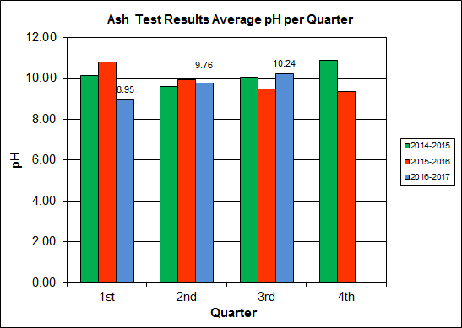

APPENDIX A  
FACILITY CEMS DATA

Table 9: Unit #1 Monthly Summary for Reportable Emissions Data

|  |  |  |  |  |  |  |  |  |  |  |
| --- | --- | --- | --- | --- | --- | --- | --- | --- | --- | --- |
| **Group#-Channel#** | | **G8-C35** | **G8-C28** | **G8-C8** | **G8-C4** | **G8-C12** | **G8-C34** | **G8-C37** | **G8-C40** | **G8-C39** |
| **Long Descrip.** | | **U-1 Steam** | **U-1 Econ** | **U-1 Stack** | **U-1 Stack** | **U-1 Stack** | **U-1 Opaci** | **U-1 FF In** | **U-1 Carbo** | **U-1 Lime** |
| **Short Descrip.** | | **SteamFl** | **SO2ec** | **SO2sc** | **COsc** | **NOxsc** | **Opacity** | **FF InTemp** | **CarbInj** | **LimeFlow** |
| **Units** | | **K#/Hr** | **ppmc** | **ppm** | **ppmc** | **ppmc** | **%** | **deg F** | **#/hr** | **gpm** |
| **Range** | | **0-100** | **0-2000** | **0-500** | **0-4000** | **0-1000** | **0-100** | **100-500** | **0-50** | **0-20** |
| Jan - 17 | AVG | 78.0 | 19.0 | 0.0 | 35.0 | 164.0 | 1.3 | 297.0 | 16.2 | 3.1 |
| Max | 82.4 | 84.0 | 2.0 | 48.0 | 184.0 | 2.0 | 300.0 | 17.0 | 3.9 |
| Min | 70.7 | 6.0 | 0.0 | 26.0 | 159.0 | 0.1 | 295.0 | 16.1 | 2.9 |
| Feb - 17 | AVG | 85.2 | 43.0 | 2.0 | 40.0 | 167.0 | 0.2 | 300.0 | 16.2 | 3.4 |
| Max | 86.9 | 97.0 | 8.0 | 61.0 | 177.0 | 0.6 | 301.0 | 16.4 | 4.4 |
| Min | 81.8 | 20.0 | 0.0 | 32.0 | 157.0 | 0.0 | 300.0 | 16.1 | 3.0 |
| Mar - 17 | AVG | 85.1 | 38.0 | 2.0 | 35.0 | 163.0 | 0.5 | 300.0 | 16.0 | 3.3 |
| Max | 90.4 | 94.0 | 10.0 | 45.0 | 171.0 | 1.3 | 304.0 | 16.2 | 4.1 |
| Min | 68.7 | 17.0 | 0.0 | 17.0 | 149.0 | 0.1 | 291.0 | 15.0 | 2.6 |
| **Quarter Average** | | 82.8 | 33.3 | 1.3 | 36.7 | 164.7 | 0.7 | 299.0 | 16.1 | 3.3 |
| **Quarter Max Value** | | 90.4 | 97.0 | 10.0 | 61.0 | 184.0 | 2.0 | 304.0 | 17.0 | 4.4 |
| **Quarter Min Value** | | 68.7 | 6.0 | 0.0 | 17.0 | 149.0 | 0.0 | 291.0 | 15.0 | 2.6 |
| **Limits:** | | 98 | NA | 29 | 100 | 205 | 10 | 333 | 16(a) |  |

(a) Carbon flow limit is a minimum value

* Note: The data reported herein represent 24 hour average data for all parameters. Emissions excursions that are measured on shorter time intervals (i.e., 4-hour block averages for CO) do not correlate with the 24 hour average data reported above.

Table 10: Unit #2 Monthly Summary for Reportable Emissions Data

|  |  |  |  |  |  |  |  |  |  |  |
| --- | --- | --- | --- | --- | --- | --- | --- | --- | --- | --- |
| **Group#-Channel#** | | **G8-C35** | **G8-C28** | **G8-C8** | **G8-C4** | **G8-C12** | **G8-C34** | **G8-C37** | **G8-C40** | **G8-C39** |
| **Long Descrip.** | | **U-2 Steam** | **U-2 Econ** | **U-2 Stack** | **U-2 Stack** | **U-2 Stack** | **U-2 Opaci** | **U-2 FF In** | **U-2 Carbo** | **U-2 Lime** |
| **Short Descrip.** | | **SteamFl** | **SO2ec** | **SO2sc** | **COsc** | **NOxsc** | **Opacity** | **FF InTemp** | **CarbInj** | **LimeFlow** |
| **Units** | | **K#/Hr** | **ppmc** | **ppm** | **ppmc** | **ppmc** | **%** | **deg F** | **#/hr** | **gpm** |
| **Range** | | **0-100** | **0-2000** | **0-500** | **0-4000** | **0-1000** | **0-100** | **100-500** | **0-50** | **0-20** |
| Jan - 17 | AVG | 80.8 | 19.0 | 0.0 | 39.0 | 159.0 | 0.5 | 300.0 | 16.1 | 3.2 |
| Max | 88.0 | 40.0 | 4.0 | 54.0 | 172.0 | 1.2 | 301.0 | 16.2 | 3.4 |
| Min | 72.1 | 9.0 | 0.0 | 28.0 | 155.0 | 0.1 | 299.0 | 15.8 | 3.0 |
| Feb - 17 | AVG | 75.2 | 30.0 | 1.0 | 28.0 | 158.0 | 0.5 | 300.0 | 16.1 | 3.2 |
| Max | 86.7 | 95.0 | 5.0 | 42.0 | 161.0 | 0.9 | 301.0 | 17.6 | 4.3 |
| Min | 54.8 | 13.0 | 0.0 | 9.0 | 156.0 | 0.2 | 299.0 | 15.9 | 3.0 |
| Mar - 17 | AVG | 91.1 | 54.0 | 2.0 | 30.0 | 165.0 | 1.1 | 298.0 | 15.9 | 3.3 |
| Max | 93.3 | 80.0 | 10.0 | 42.0 | 178.0 | 1.7 | 300.0 | 16.2 | 4.4 |
| Min | 87.2 | 37.0 | 0.0 | 23.0 | 157.0 | 0.5 | 298.0 | 14.8 | 3.0 |
| **Quarter Average** | | 82.4 | 34.3 | 1.0 | 32.3 | 160.7 | 0.7 | 299.3 | 16.0 | 3.2 |
| **Quarter Max Value** | | 93.3 | 95.0 | 10.0 | 54.0 | 178.0 | 1.7 | 301.0 | 17.6 | 4.4 |
| **Quarter Min Value** | | 54.8 | 9.0 | 0.0 | 9.0 | 155.0 | 0.1 | 298.0 | 14.8 | 3.0 |
| **Limits:** | | 96 | NA | 29 | 100 | 205 | 10 | 330 | 16(a) |  |

(a) Carbon flow limit is a minimum value

* Note: The data reported herein represent 24 hour average data for all parameters. Emissions excursions that are measured on shorter time intervals (i.e., 4-hour block averages for CO) do not correlate with the 24 hour average data reported above.

Table 11: Unit #3 Monthly Summary for Reportable Emissions Data

|  |  |  |  |  |  |  |  |  |  |  |
| --- | --- | --- | --- | --- | --- | --- | --- | --- | --- | --- |
| **Group#-Channel#** | | **G8-C35** | **G8-C28** | **G8-C8** | **G8-C4** | **G8-C12** | **G8-C34** | **G8-C37** | **G8-C40** | **G8-C39** |
| **Long Descrip.** | | **U-3 Steam** | **U-3 Econ** | **U-3 Stack** | **U-3 Stack** | **U-3 Stack** | **U-3 Opaci** | **U-3 FF In** | **U-3 Carbo** | **U-3 Lime** |
| **Short Descrip.** | | **SteamFl** | **SO2ec** | **SO2sc** | **COsc** | **NOxsc** | **Opacity** | **FF InTemp** | **CarbInj** | **LimeFlow** |
| **Units** | | **K#/Hr** | **ppmc** | **ppm** | **ppmc** | **ppmc** | **%** | **deg F** | **#/hr** | **gpm** |
| **Range** | | **0-100** | **0-2000** | **0-500** | **0-4000** | **0-1000** | **0-100** | **100-500** | **0-50** | **0-20** |
| Jan - 17 | AVG | 82.4 | 23.0 | 1.0 | 33.0 | 159.0 | 0.0 | 298.0 | 16.1 | 3.2 |
| Max | 90.1 | 58.0 | 13.0 | 44.0 | 162.0 | 0.0 | 298.0 | 16.6 | 3.8 |
| Min | 74.4 | 12.0 | 0.0 | 24.0 | 158.0 | 0.0 | 297.0 | 16.0 | 2.9 |
| Feb - 17 | AVG | 80.0 | 23.0 | 0.0 | 29.0 | 159.0 | 0.0 | 298.0 | 16.1 | 3.1 |
| Max | 84.7 | 49.0 | 3.0 | 36.0 | 161.0 | 0.0 | 301.0 | 16.3 | 3.2 |
| Min | 75.0 | 10.0 | 0.0 | 21.0 | 158.0 | 0.0 | 296.0 | 16.1 | 3.0 |
| Mar - 17 | AVG | 89.4 | 58.0 | 2.0 | 31.0 | 163.0 | 0.2 | 298.0 | 16.0 | 3.3 |
| Max | 93.7 | 92.0 | 8.0 | 40.0 | 173.0 | 0.7 | 299.0 | 16.4 | 4.2 |
| Min | 78.7 | 30.0 | 0.0 | 17.0 | 156.0 | 0.0 | 297.0 | 15.0 | 3.0 |
| **Quarter Average** | | 83.9 | 34.7 | 1.0 | 31.0 | 160.3 | 0.1 | 298.0 | 16.1 | 3.2 |
| **Quarter Max Value** | | 93.7 | 92.0 | 13.0 | 44.0 | 173.0 | 0.7 | 301.0 | 16.6 | 4.2 |
| **Quarter Min Value** | | 74.4 | 10.0 | 0.0 | 17.0 | 156.0 | 0.0 | 296.0 | 15.0 | 2.9 |
| **Limits:** | | 98 | NA | 29 | 100 | 205 | 10 | 327 | 16(a) |  |

(a) Carbon flow limit is a minimum value

* Note: The data reported herein represent 24 hour average data for all parameters. Emissions excursions that are measured on shorter time intervals (i.e., 4-hour block averages for CO) do not correlate with the 24 hour average data reported above.

APPENDIX B  
SITE PHOTOS – FEBRUARY 2017

|  |  |
| --- | --- |
| C:\Users\kperrin\Desktop\February 2017\P1030195.JPG  Figure 1: Housing Damaged of Self Contained Breathing Apparatus (SCBA) – North Charging Floor Entrance – New Deficiency | C:\Users\kperrin\Desktop\February 2017\P1030187.JPG  Figure 2: Tipping Floor Center Bay concrete apron eroded and rebar exposed – New Deficiency |
| C:\Users\kperrin\Desktop\February 2017\P1030184.JPG  Figure 3: New refuse pit warning laser lights – red line projected near refuse pit edge | C:\Users\kperrin\Desktop\February 2017\P1030213.JPG  Figure 4: Ceiling mounted laser projector for refuse pit warning laser system – multiple units installed all the way across Tipping Enclosure Roof |
| C:\Users\kperrin\Desktop\February 2017\P1030218.JPG  Figure 5: General Facility Photo – Northeast Corner | C:\Users\kperrin\Desktop\February 2017\P1030227.JPG  Figure 6: General Facility Photo |
| C:\Users\kperrin\Desktop\February 2017\P1030229.JPG  Figure 7: Ash Trailer Canopy | C:\Users\kperrin\Desktop\February 2017\P1030230.JPG  Figure 8: Ammonia Storage Tank |
| C:\Users\kperrin\Desktop\February 2017\P1030231.JPG  Figure 9: Administration Office Space Renovations – In Progress | C:\Users\kperrin\Desktop\February 2017\P1030235.JPG  Figure 10: First floor restrooms completely renovated |
| C:\Users\kperrin\Desktop\February 2017\P1030236.JPG  Figure 11: Administration Office 1st Floor Lobby Renovations – In Progress | **C:\Users\kperrin\Desktop\February 2017\P1030199.JPG**  Figure 12: New Covanta Sign – Freshly painted |
| C:\Users\kperrin\Desktop\February 2017\P1030202.JPG  Figure 13: Outage materials staged throughout Barn Door Elevation – awaiting Spring Outages | C:\Users\kperrin\Desktop\February 2017\P1030205.JPG  Figure 14: General Photo – Economizer Area |
| C:\Users\kperrin\Desktop\February 2017\P1030206.JPG  Figure 15: Multiple Cooling Tower Access Stairs replaced with new pressure treated wood – Satisfies Deficiency Item 12 – Reported in November 2016 | C:\Users\kperrin\Desktop\February 2017\P1030207.JPG  Figure 16: Grate bars awaiting installation during Spring Outages |
| C:\Users\kperrin\Desktop\February 2017\P1030210.JPG  Figure 17: Circulating Water Pumps – east side of Cooling Tower | C:\Users\kperrin\Desktop\February 2017\P1030212.JPG  Figure 18: Tipping Floor – General Photo |
| C:\Users\kperrin\Desktop\February 2017\P1030214.JPG  Figure 19: Metal Roll-Off | C:\Users\kperrin\Desktop\February 2017\P1030217.JPG  Figure 20: Citizen’s Drop – Roll-off |
| C:\Users\kperrin\Desktop\February 2017\P1030178.JPG  Figure 21: Firing Aisle | C:\Users\kperrin\Desktop\February 2017\P1030179.JPG  Figure 22: Turbine Generator Enclosure |
| C:\Users\kperrin\Desktop\February 2017\P1030182.JPG  Figure 23: Cooling Towers from SDA Penthouse | C:\Users\kperrin\Desktop\February 2017\P1030183.JPG  Figure 24: Deaerator |
| C:\Users\kperrin\Desktop\February 2017\P1030198.JPG  Figure 25: SCBA at north Charging Floor Entrance | C:\Users\kperrin\Desktop\February 2017\P1030222.JPG  Figure 26: Fire House at east Tipping Enclosure Wall – No Issues Observed |
| C:\Users\kperrin\Desktop\February 2017\P1030189.JPG  Figure 27: Charging Floor Fire Cannon on West side of Refuse Pit Parapet – No Issues Observed | C:\Users\kperrin\Desktop\February 2017\P1030191.JPG  Figure 28: Charging Floor Fire Cannon, north end of Charging Floor - No Issues Observed |
| C:\Users\kperrin\Desktop\February 2017\P1030193.JPG  Figure 29: Fire Hose north end of Charging Floor – No Issues Observed | C:\Users\kperrin\Desktop\February 2017\P1030200.JPG  Figure 30: Fire Alarm Operator Interface in Control Room - CAAI 2017 Budget Item to upgrade |